Option #1: Implementing SAS Hypothesis Testing
Alisha Fine
Colorado State University – Global Campus
Option #1: Implementing SAS Hypothesis Testing
- The code copied from SAS
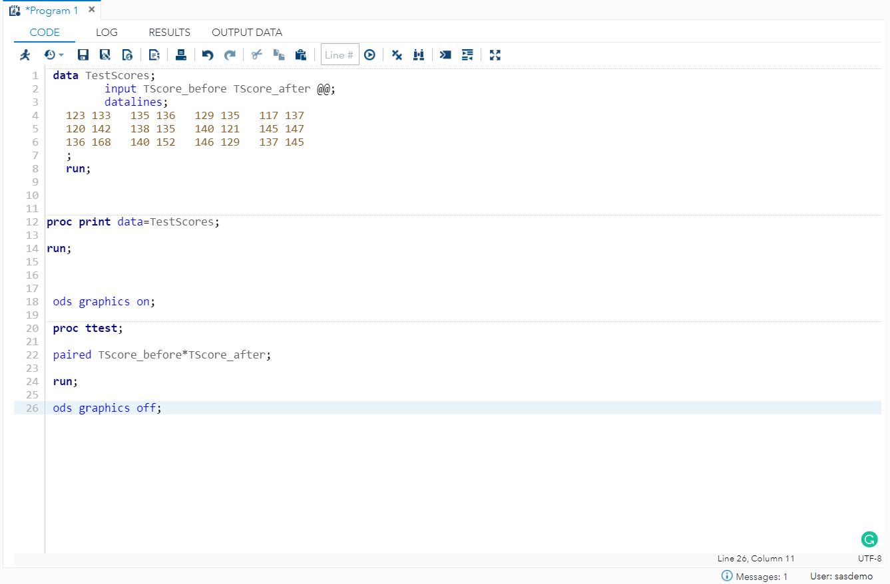
Figure 1. Screen shot of code from SAS
- Output
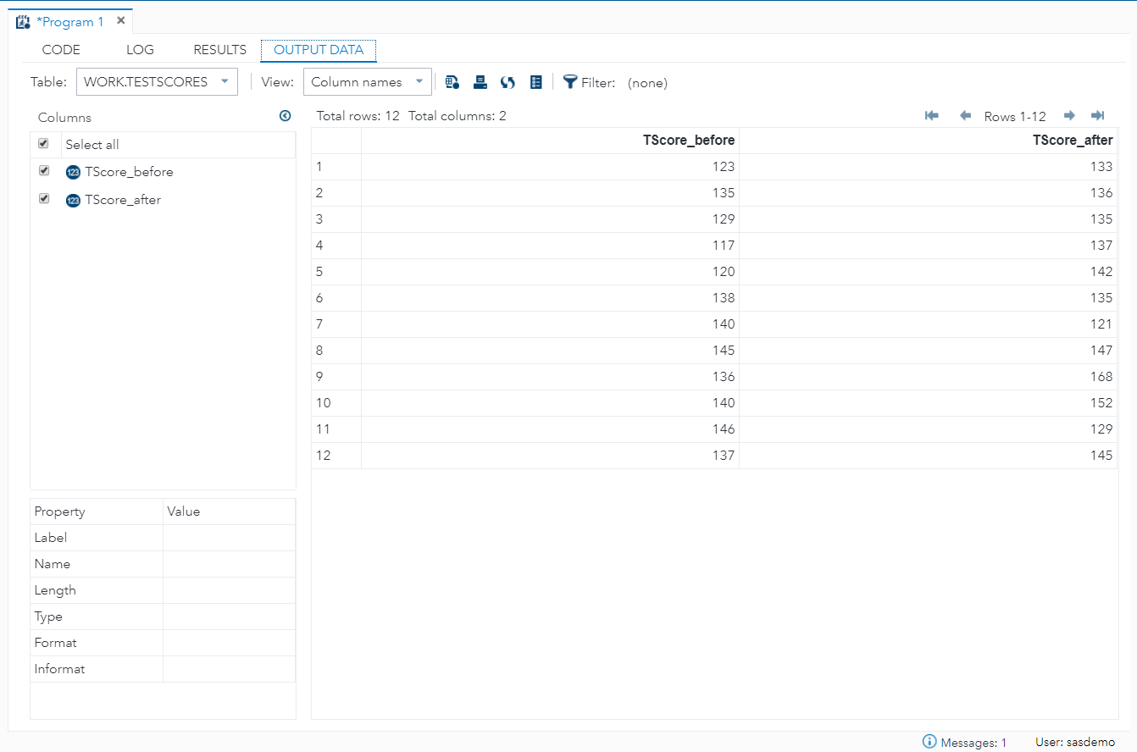
Figure 2. Screenshot of output data

- Graphs
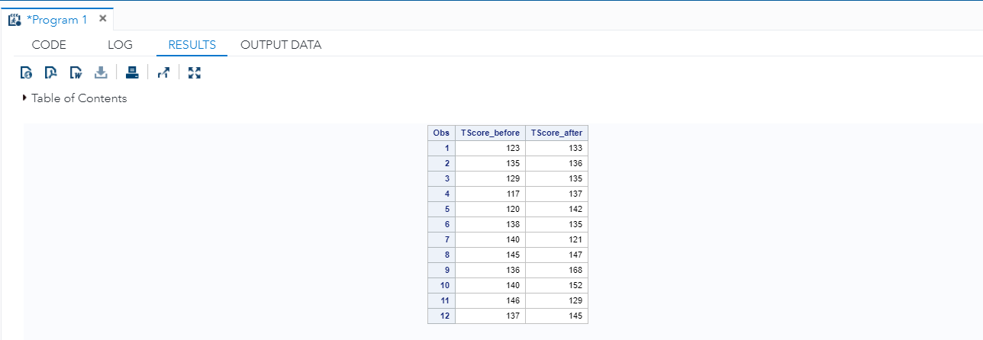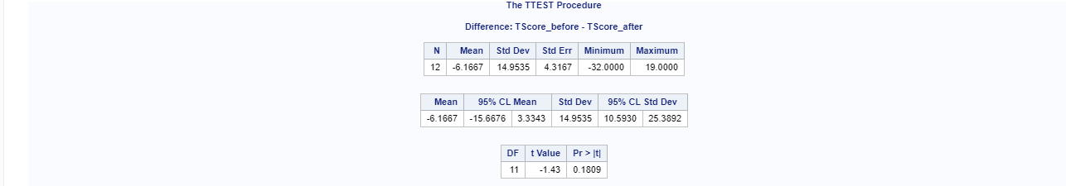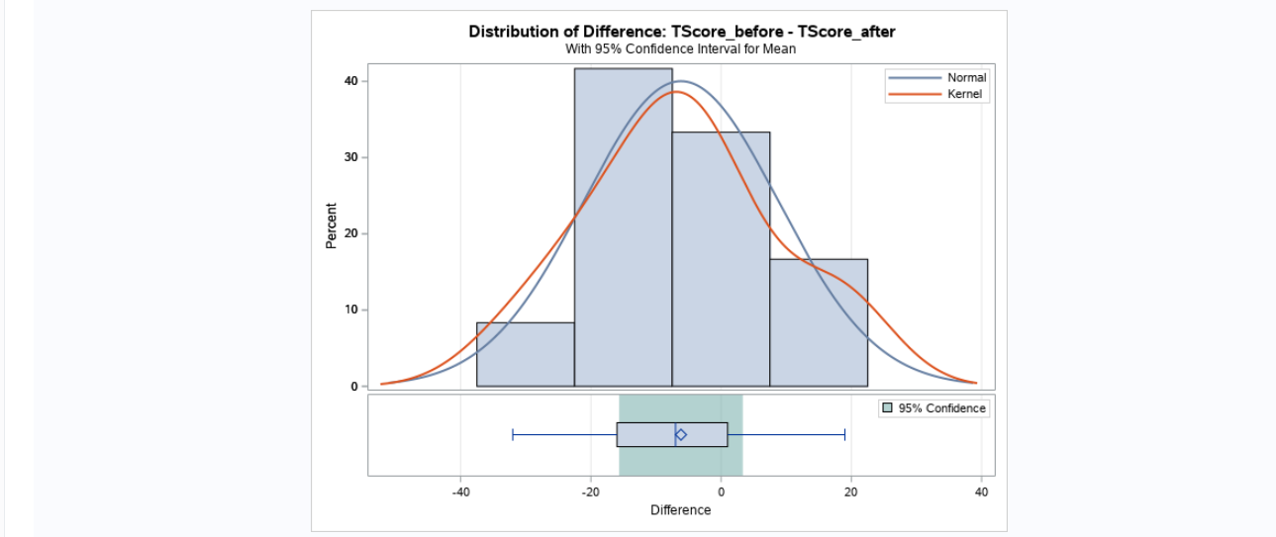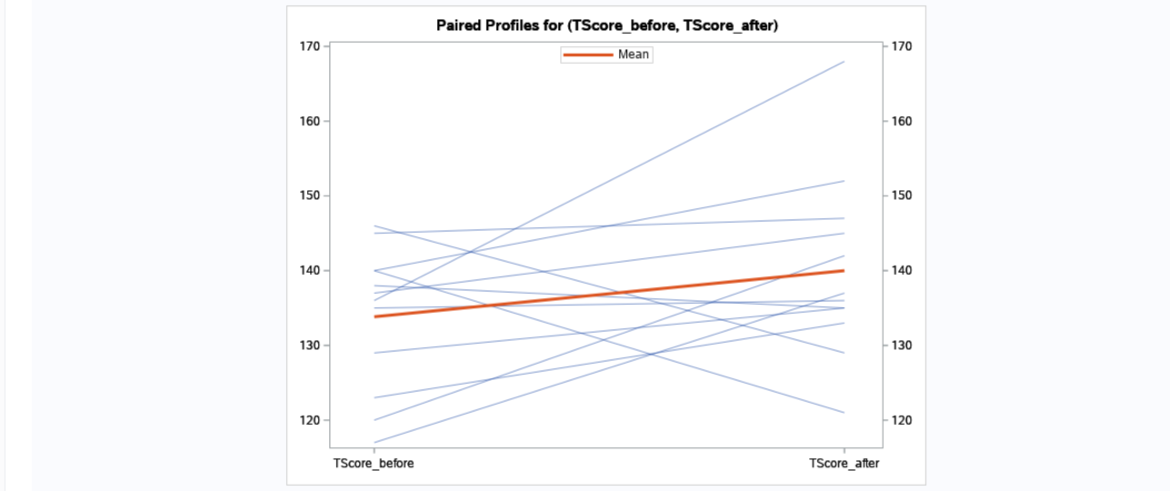
Figure 3. First screenshot of graphs
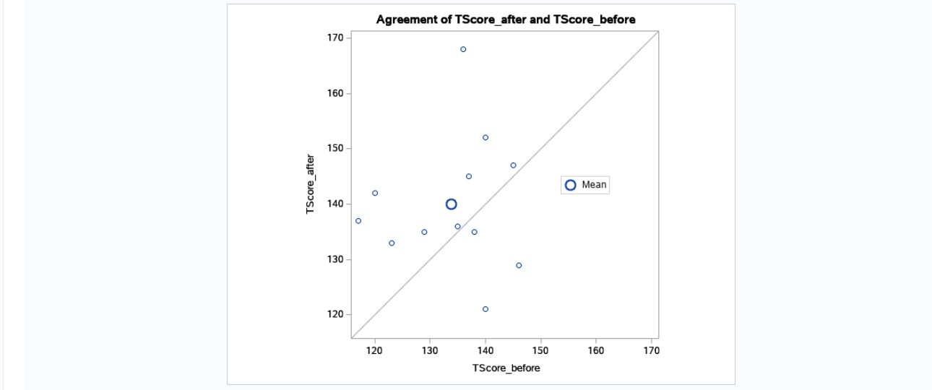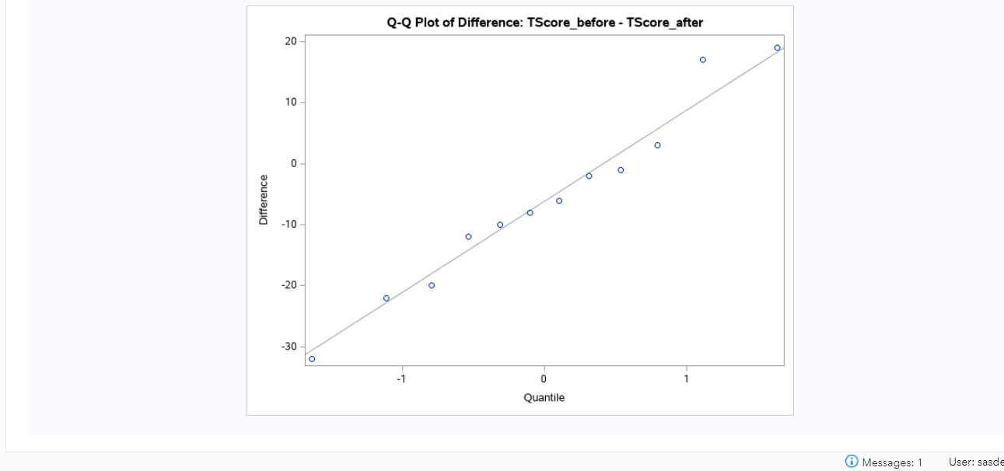
Figure 4. Second screenshot of graphs

